Stock Market Dataset
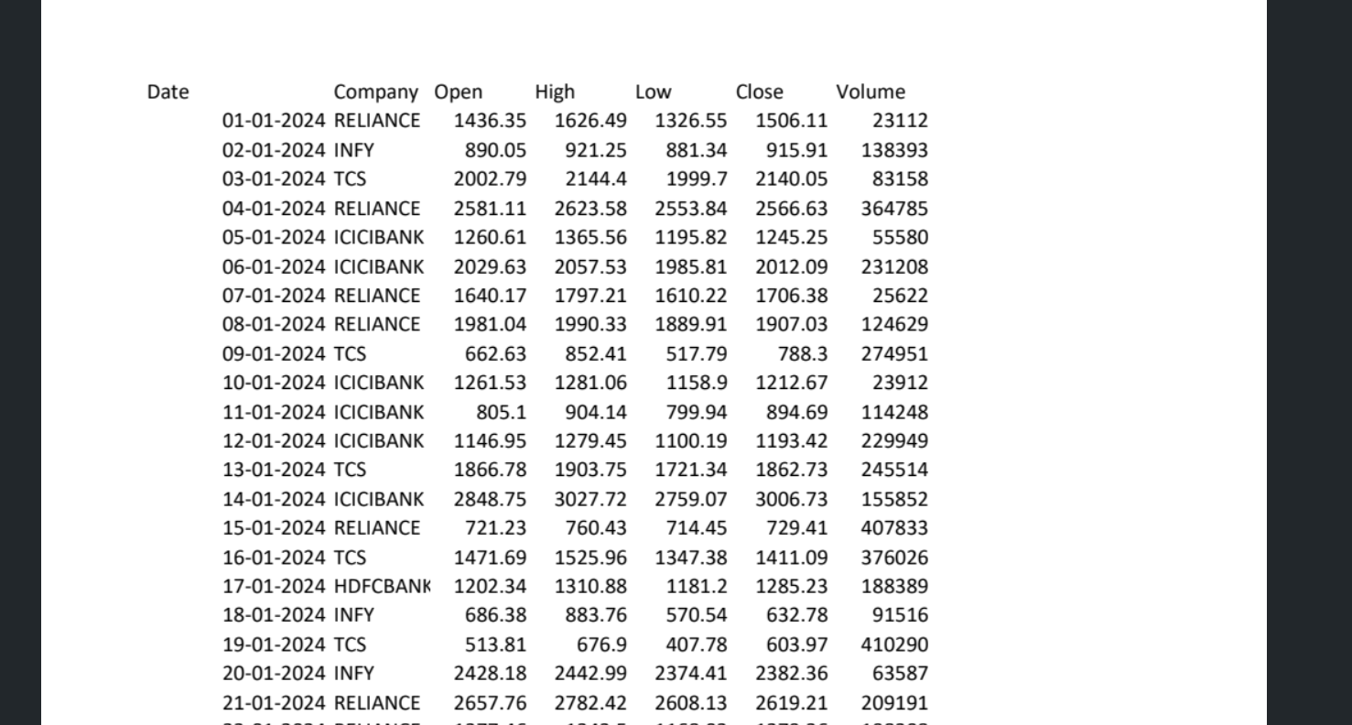
Dataset Description: Stock Market Dataset
This dataset contains historical stock market data for different companies from January 2024 onwards. It records daily stock prices and trading volumes for companies such as Reliance, Infosys (INFY), TCS, ICICI Bank, and HDFC Bank.
The dataset can be used to analyze stock price movements, compare company performance, identify trends, and predict future stock prices.
Description of Each Column
1. Date
- Represents the date on which the stock market data was recorded.
- Example: 01-01-2024.
2. Company
- Represents the name or stock symbol of the company.
- Examples: RELIANCE, INFY, TCS, ICICIBANK, HDFCBANK.
3. Open
- Represents the stock price at the beginning of the trading session.
- Example: Reliance opened at ₹1,436.35 on 01-01-2024.
4. High
- Represents the highest stock price reached during the trading session.
- Example: Reliance reached a high of ₹1,626.49 on 01-01-2024.
5. Low
- Represents the lowest stock price reached during the trading session.
- Example: Reliance reached a low of ₹1,326.55 on 01-01-2024.
6. Close
- Represents the stock price at the end of the trading session.
- Example: Reliance closed at ₹1,506.11 on 01-01-2024.
7. Volume
- Represents the number of shares traded during the trading session.
- Example: A volume of 23,112 means 23,112 shares were traded, assuming the dataset records individual shares.

